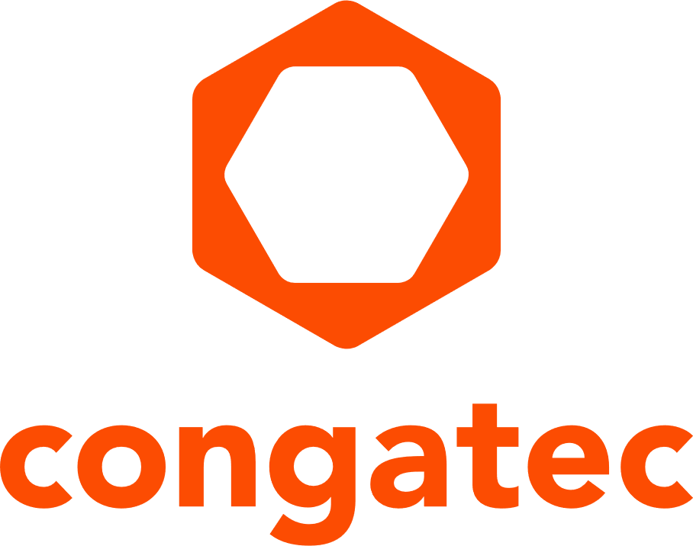
Press release

congatec and Qualcomm collaborate to drive the next technology wave with high-performance Qualcomm Dragonwing platforms

congatec embedded Computer-on-Modules accelerate rugged high-performance edge AI with Qualcomm Dragonwing™ processors


“Our new technology collaboration with Qualcomm Technologies allows developers to achieve the same level of extreme computing performance and interface bandwidth with a power-efficient design that was only possible with x86 architectures for decades,” said Konrad Garhammer, CTO & COO at congatec.


“Our collaboration with congatec combines best-in-class compute performance, industry-leading power efficiency, on-device AI and industrial-grade features of the Dragonwing IQ-X Series with the flexibility, scalability and ruggedness of congatec’s COM-HPC Mini portfolio and application-ready ecosystem,” said Enrico Salvatori, Senior Vice President and President of Qualcomm Europe, Inc.

San Diego, CA, November 18, 2025 * * * congatec – a leading vendor of embedded and edge computing technology – today announced a technology collaboration with Qualcomm Technologies, Inc. that will speed the commercialization of high-performance embedded edge AI applications for size, power, and weight (SWaP) constrained industrial products based on Qualcomm Dragonwing™ processors. In a first step, the technology collaboration unlocks the versatility of congatec’s application-ready COM-HPC Mini Computer-on-Modules portfolio for developers using Qualcomm Dragonwing IQ-X Series processors.

“Our new technology collaboration with Qualcomm Technologies allows developers to achieve the same level of extreme computing performance and interface bandwidth with a power-efficient design that was only possible with x86 architectures for decades,” said Konrad Garhammer, CTO & COO, congatec. “For the first time, developers can create high-end embedded applications that leverage the outstanding energy efficiency and performance per watt for the most performance-intensive embedded hardware on a form factor that’s nearly the size of a credit card.”

“Our collaboration with congatec combines best-in-class compute performance, industry-leading power efficiency, on-device AI and industrial-grade features of the Dragonwing IQ-X Series with the flexibility, scalability and ruggedness of congatec’s COM-HPC Mini portfolio and application-ready ecosystem,” said Enrico Salvatori, Senior Vice President and President of Qualcomm Europe, Inc. “Together, we are driving the transformation of intelligent industries by delivering superior platforms that empower customers to create next-generation industrial PCs, and deploy edge AI applications at scale.”

About congatec COM-HPC Mini
congatec’s COM-HPC Mini ecosystem of embedded modules is based on PCI Industrial Computer Manufacturers Group (PICMG)’s COM-HPC base specification. Measuring just 95 mm x 70 mm, COM-HPC Mini with Dragonwing IQ-X Series processors target the growing demand for high-performance power-efficient edge AI applications in markets such as security, retail/POS, robotics, medical technology, and industrial automation. Offering an increased performance density, congatec’s COM-HPC Mini ecosystem is ideally suited for all size, weight, and power (SWAP) optimized applications that rely on situational awareness (e.g., vision, sounds, and sensors) as well as local edge AI. Mobile medical devices, security kiosks, point-of-sale self-checkout systems, autonomous vehicles, and applications that run large language models locally are also well-matched.

For more information, visit: https://www.congatec.com/en/ecosystems/com-hpc-mini-ecosystem.

###

About congatec
congatec is a leading global provider of high-performance hardware and software building blocks for embedded and edge computing solutions based on Computer-on-Modules (COMs). These advanced computer modules drive systems and devices across industries such as industrial automation, medical technology, robotics, telecommunications, and more. congatec's high-performance aReady. ecosystems simplify and accelerate the solution development, from COM to cloud. This application-ready approach combines COMs with services and customizable technologies that enable cutting-edge advancements in system consolidation, IoT, security, and artificial intelligence. Supported by its majority shareholder, DBAG Fund VIII – a German mid-market fund focused on driving growth for industrial enterprises – congatec has the financial backing and M&A expertise to capitalize on expanding market opportunities. For more information, visit www.congatec.com or follow us on LinkedIn and YouTube.

Qualcomm branded products are products of Qualcomm Technologies, Inc. and/or its subsidiaries. Qualcomm patents are licensed by Qualcomm Incorporated.

Reader Enquiries:
congatec
Dan Demers
Phone: 858-457-2600
Dan.Demers@congatec.com
www.congatec.us

Press Contact:
congatec
Janene Rae
Phone: 858-457-2600
janene.rae@congatec.com
www.congatec.us

