
Press release

congatec launches COM Express Compact module based on the latest AMD Ryzen™ AI Embedded P100 processor series

Computer-on-Modules for an efficient entry into rugged embedded edge AI applications

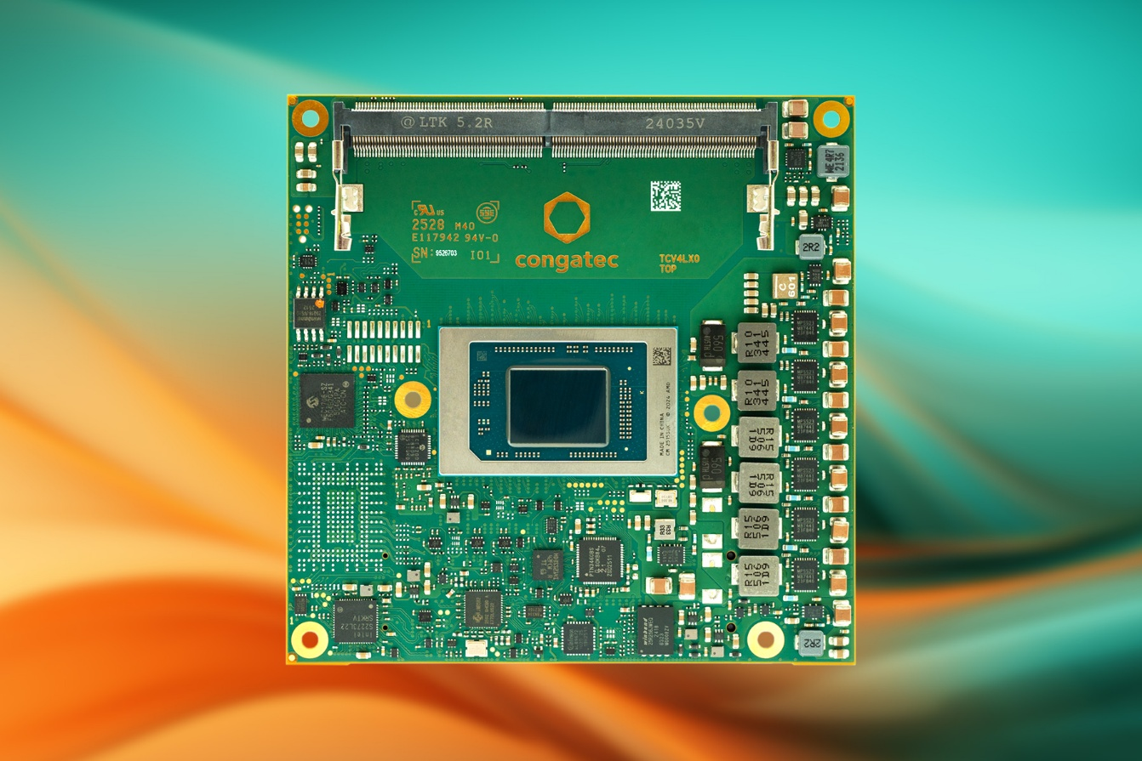

San Diego, CA, January 20, 2026 * * * congatec – the leading provider of embedded and edge computing technology – today launched a new COM Express 3.1 Type 6 Compact module series. The new conga-TCRP1 modules are based on the latest AMD Ryzen™ AI Embedded P100 Series processors with 4 or 6 cores and support the industrial temperature range from -40 to +85 °C. The new modules are designed to provide an efficient entry into industrial edge AI applications across markets including transportation, medical, smart city infrastructure, gaming, point-of-sale, robotics, and industrial automation. They accelerate embedded computing applications with up to 59 TOPS of combined AI inference performance, with up to 50 TOPS provided by the XDNA2 NPU, and the remaining performance delivered by up to 6 AMD Zen5 CPU cores and the RDNA3.5 GPU. Customers who want to balance their application between efficient CPU/GPU/NPU performance, configurable thermal design power (TDP) from 15 to 54 W, and SWaP-C requirements (size, weight, power, cost) will particularly benefit from the high scalability of the new modules.

Rugged and scalable for mission-critical applications
With the conga-TCRP1, congatec is expanding its extensive product portfolio of AI-accelerating x86 Computer-on-Modules (COMs) with a module that offers an industrial temperature range of -40 to +85 °C. Customers can easily scale their applications across a wide range of performance and power requirements. The minimum configurable TDP of just 15 W simplifies the development of passively cooled, completely enclosed designs. This makes the new conga-TCRP1 ideal for use in rugged handheld devices, hygienic medical PCs, and mission-critical devices in harsh environments.

"With the increasing demand for rugged edge applications with or without AI, there is also a growing need for entry-level COM variants with 4 and 6 cores for power- and cost-optimized designs. The conga-TCRP1 expands congatec's comprehensive portfolio for precisely these application areas, targeting cost-sensitive designs that require optimal performance per watt," said Florian Drittenthaler, Product Line Manager at congatec.

The feature set in detail
The computing cores of the conga-TCRP1 are based on the AMD Zen5 architecture with performance-oriented Zen5 cores combined with Zen5c cores designed for maximum energy efficiency. This ensures extremely low power consumption of the modules while delivering high overall efficiency and a single-thread performance of up to 4.5 GHz. A key advantage for application developers is that the Zen5 and Zen5c cores are based on the same architecture. This ensures consistent execution timing in deterministic applications and optimizes real-time performance.

In addition to the Zen5/5c cores and the Radeon™ RDNA 3.5™ GPU, which supports up to 4 independent display connections with immersive 4k graphics, the integrated XDNA2 NPU provides up to 50 TOPS of AI performance. This enables to run real-time processing of smaller large language models (LLMs) locally – without cloud connectivity or discrete accelerators, and in a cost- and energy-efficient manner.

At the same time, memory-intensive applications benefit from up to 96 GB of DDR5-5600 RAM with optional Error Correction Code (ECC) for mission-critical applications. Up to 8 fully configurable PCIe Gen4 lanes and PEG x4 Gen4 are available for fast data transfer and the connection of low-lane peripherals such as Industrial Ethernet, fieldbus adapters, or radio modules. In addition, 2.5 GbE ensures fast networking, and 4x USB 3.2 Gen2 and 4x USB 2.0 provide connections for additional devices. For data storage, the modules offer up to 512 GB of onboard NVMe SSD or 2x SATA 6Gb/s for external media. 1x I²C bus, GPSPI, 2x UART, 8x GPIO, 1x SMBus, and 1x LPC round out the feature set. The adjustable TDP from 15 to 54 W ensures that customer applications can be easily adapted to individual requirements without having to implement new product versions with other derivatives.

Supported operating systems include Microsoft Windows 11, Windows 11 IoT Enterprise, Linux, ctrlX OS, Ubuntu Pro, and Kontron OS. As application-ready aReady.COMs, the modules can be preconfigured with licensed ctrlX OS, Ubuntu Pro, and KontronOS. The aReady.VT option with integrated hypervisor-on-module enables developers to consolidate multiple workloads, such as real-time control, HMI, AI and IoT gateway functions, on a single module. For IIoT connectivity, congatec offers aReady.IOT software building blocks. These enable data exchange, remote maintenance and management of the module, carrier board and peripherals, as well as cloud connectivity, if required. To further simplify application development, congatec offers a comprehensive accompanying ecosystem that includes evaluation and application-ready carrier boards, customized cooling solutions, comprehensive documentation, design-in services, and high-speed signal integrity measurements.

The new conga-TCRP1 modules are available in the following variants:
Model | CPU Cores | GPU Compute Units | Clock Speed (max. boost) | Base TDP | Operating Temperature
conga-TCRP1/P132 | 6 / 12 | 4 | 4.5 GHz | 28 (15-54 W) | 0 to +60 °C
conga-TCRP1/P121 | 4 / 8 | 2 | 4.4 GHz | 28 (15-54 W) | 0 to +60 °C
conga-TCRP1/P132i | 6 / 12 | 4 | 4.5 GHz | 28 (15-54 W) | -40 to +85°C
conga-TCRP1/P121i | 4 / 8 | 2 | 4.4 GHz | 28 (15-54 W) | -40 to +85 °C

For more information on the COM Express Type 6 Compact Module conga-TCRP1, please visit: https://www.congatec.COM/us/products/COM-express-type-6/conga-tcrp1/

* * *
About congatec
congatec is the leading global provider of high-performance hardware and software building blocks for embedded and edge computing solutions based on Computer-on-Modules (COMs). These advanced computer modules drive systems and devices across industries such as industrial automation, medical technology, robotics, telecommunications, and more. congatec's high-performance aReady. ecosystems simplify and accelerate the solution development, from COM to cloud. This application-ready approach combines COMs with services and customizable technologies that enable cutting-edge advancements in system consolidation, IoT, security, and artificial intelligence. Supported by its majority shareholder, DBAG Fund VIII – a German mid-market fund focused on driving growth for industrial enterprises – congatec has the financial backing and M&A expertise to capitalize on expanding market opportunities. For more information, visit congatec.com, aReady.com, or follow us on LinkedIn and YouTube.

Reader Enquiries:
congatec
Dan Demers
Phone: 858-457-2600
Dan.Demers@congatec.com
www.congatec.us

Press Contact:
congatec
Janene Rae
Phone: 858-457-2600
janene.rae@congatec.com
www.congatec.us

