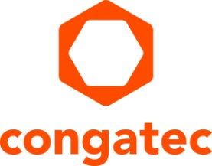
Presse release

congatec extends aReady.COM to Arm based modules – application-ready hardware and software building blocks, complete with OS, system consolidation, and IoT connectivity for value-generating applications based on NXP i.MX 95 applications processor

aReady.COM conga-SMX95 optimizes time-to-market and expands usage potential

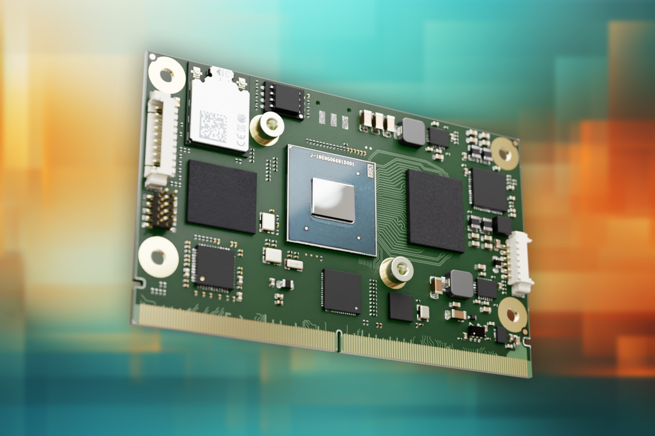

Nuremberg, Germany/San Diego, CA, March 10, 2026 * * * congatec – the leading provider of embedded and edge computing technology – is extending its portfolio of application-ready aReady. software building blocks to include Arm-based Computer-on-Modules. The first product in this expansion is the successful SMARC module conga-SMX95, based on NXP® Semiconductors’ i.MX 95 applications processors. With application-ready hardware and software building blocks – including OS, system consolidation, and IoT connectivity – the new aReady.COM enables OEMs to bring value-generating applications to market faster. By also addressing the high variability of Arm designs, congatec significantly reduces software bring-up complexity for OEMs. This will simplify the transition to Arm technology for many developers who previously avoided using Arm processors.

“Compared to x86, Arm designs often require greater initial integration effort, but offer higher efficiency,” explains Martin Danzer, Director Product Management at congatec. “With aReady.COM for Arm based on the NXP i.MX 95 applications processor, we provide our customers with tangible value adds that accelerate time-to-dollar and maximize the business impact of their applications, enabling them to serve their addressable markets more effectively. Preconfigured, installed, and licensed core functions and software for operation, system consolidation, and IoT connectivity make the congatec module a highly efficient solution. Customers who previously avoided Arm designs due to their complexity can now leverage the aReady framework as a design foundation with optimally coordinated hardware and software.”

“The combination of congatec’s pre-integrated software stacks with the i.MX 95 applications processor’s advanced compute, AI acceleration, and secure, real-time architecture enables OEMs to shorten development cycles for industrial applications,” said Robert Thompson, Partner Marketing Director at NXP Semiconductors. “congatec’s support of the NXP i.MX 95 SoC helps customers simplify the path to high performance Arm based designs.”

“aReady.COMs combine the advantages of standardized modules with pre-integrated software and technology stacks, creating real value-add in the embedded computing environment,” adds Andreas Bergbauer, Manager Solution Management at congatec. “By handling tasks that are routine for us as a module manufacturer but consistently challenging for OEMs, our aReady.COMs enable customers to focus on their core competencies and build best-in-class solutions.”

aReady.COM modules offer a flexible combination of application-ready software building blocks on a fully customizable Computer-on-Module, minimizing setup and configuration effort. OEMs can optionally get the conga-SMX95 module preconfigured with a bootloader, installed and licensed operating systems such as Ubuntu or Kontron OS, a configured hypervisor for system consolidation, and the aReady.IoT software conga-connect. conga-connect integrates software functions for device management, simple setup and configuration of cyber-secure IIoT connectivity, and remote application management. Customers enjoy significantly reduced design-in effort, faster time-to-market, and a substantially smaller bill of materials.

aReady.COMs also support customers in certifying their applications according to IEC 62443, with fundamental security requirements fulfilled out of the box. At the highest integration level, congatec can even pre-install the customer’s application software, so the module can be plugged into the carrier board and booted immediately.

Further information about the conga-SMX95 aReady.COM SMARC module is available at: https://www.congatec.com/en/products/smarc/conga-smx95/

For further information about aReady.COM, visit https://aready.com/

* * *

About congatec
congatec is the leading global provider of high-performance hardware and software building blocks for embedded and edge computing solutions based on Computer-on-Modules (COMs). These advanced computer modules drive systems and devices across industries such as industrial automation, medical technology, robotics, telecommunications, and more. congatec's high-performance aReady. ecosystems simplify and accelerate the solution development, from COM to cloud. This application-ready approach combines COMs with services and customizable technologies that enable cutting-edge advancements in system consolidation, IoT, security, and artificial intelligence. Supported by its majority shareholder, DBAG Fund VIII – a German mid-market fund focused on driving growth for industrial enterprises – congatec has the financial backing and M&A expertise to capitalize on expanding market opportunities. For more information, visit congatec.com, aReady.com, or follow us on LinkedIn and YouTube.

Reader Enquiries:
congatec
Dan Demers
Phone: 858-457-2600
Dan.Demers@congatec.com
www.congatec.us

Press Contact:
congatec
Janene Rae
Phone: 858-457-2600
janene.rae@congatec.com
www.congatec.us

