
Press release

More consistent power for COM-HPC client platforms

conga-HPC/cBLS accelerates demanding edge designs
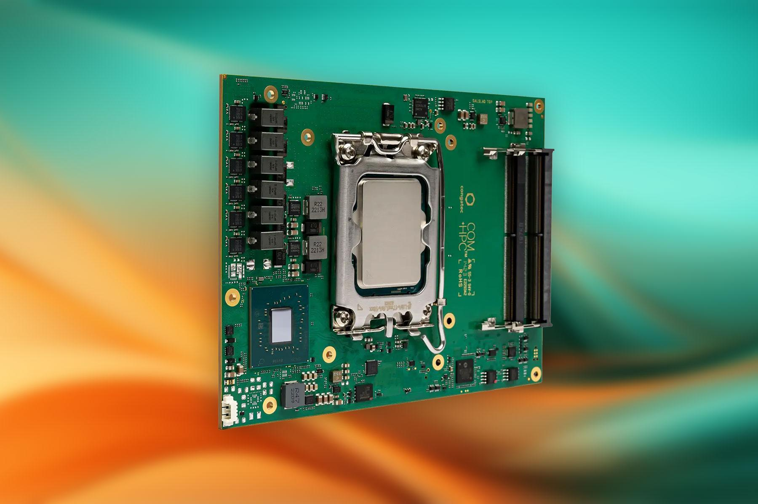

San Diego, CA, March 10, 2026 * * * congatec – the leading vendor of embedded and edge computing technology – is expanding the performance envelope of its COM-HPC Client Size C Computer-on-Modules (COMs), conga-HPC/cBLS, with new Intel® Core™ Series 2 variants (codename: Bartlett Lake-S) based exclusively on high-performance P-cores. Featuring up to 12 identical P-cores, the new modules are specially designed for deterministic high-end applications that need to process numerous data streams in parallel. They support up to 192 GB of RAM and provide 42 PCIe lanes for high-bandwidth connectivity in advanced I/O technologies or AI accelerator cards. This makes them ideally suited for performance-hungry edge computing applications in markets such as test & measurement, medical imaging, smart grids, energy systems, robotics, and industrial process automation—applications that require server-class performance in a workstation-class design footprint.

Deterministic high-end embedded computing at up to 5.7 GHz
The new modules provide a homogeneous CPU architecture with a unified instruction set, simplifying the development of low-latency systems with fully deterministic behavior. Powered by high-performance yet cost-efficient LGA processors, the conga-HPC/cBLS delivers maximum compute capability at CPU frequencies of up to 5.7 GHz.
This performance directly benefits applications such as data loggers in stationary or mobile test benches, precision real-time control systems for robots, CNC machines, and automated production lines, as well as AI-based quality inspection systems.
In addition to its modular architecture, the conga-HPC/cBLS future-proofs upgrade paths via straightforward module replacement through high-performance computing sockets.

“Thanks to their outstanding performance-per-euro ratio, our COM-HPC Client Size C modules with socketed processors present an attractive alternative to traditional motherboards—especially for system designs with high performance and scalability requirements that demand regular technology refresh cycles,” explains Jürgen Jungbauer, Senior Product Line Manager at congatec. “Leveraging the integrated graphics with Intel Deep Learning Boost as a GPGPU further transforms the module into a highly efficient, low-power server platform for AI inference at the edge.”

Impressive AI inference performance for edge AI
Applications also benefit from the strong AI acceleration capabilities of the integrated Intel UHD Graphics featuring up to 32 execution units. It supports Intel® Deep Learning Boost and Vector Neural Network Instructions (VNNI), enabling efficient AI inference at the edge. Up to 192 GB of ECC-protected memory across four SO-DIMM sockets further accelerates GPGPU workloads and data-intensive edge applications. Dual 2.5 Gigabit Ethernet interfaces, extensive I/O options including four USB 3.2 ports, four USB 2.0 ports, SATA, UART, GPIO, I2C, and high-definition audio round out the feature set.
Comprehensive active cooling solutions ensure efficient thermal management. Using heat spreaders and heat pipe adapters, even fully sealed system designs can be realized.
The conga-HPC/cBLS supports Microsoft Windows 11, Windows 11 IoT Enterprise, Linux, and Ubuntu Pro. These application-ready aReady.COM modules can be preconfigured with licensed ctrlX OS, Ubuntu Pro, or KontronOS.

The aReady.VT option with an integrated conga-zones hypervisor enables developers to consolidate multiple workloads—including real-time control, HMI, AI, and IoT gateway functionality—onto a single module. For IIoT connectivity, developers can leverage the conga-connect software building blocks, which enable data exchange as well as remote monitoring and management of the module, carrier board, and peripherals, including secure cloud connectivity. To further streamline application development, congatec provides a comprehensive ecosystem, including evaluation and application-ready carrier boards. Also available are aReady.YOURS customization services for COMs, carrier boards, and thermal solutions—up to and including full custom designs.

CPU |  | Cores/  (P + E) |  | P-cores  Takt [GHz]  (Base) |  | P-cores  Takt [GHz]  (Single P-Core Turbo / All P-Core Turbo) |  |  | GFX EUs |  | CPU Base Power [W]
Intel Core 9 273PE |  | 12 (12+0) |  | 2,3 |  | 5,7 / 5,2 |  |  | 32 |  | 65
Intel Core 7 253PE |  | 10 (10+0) |  | 2,5 |  | 5,5 / 5,1 |  |  | 32 |  | 65
Intel Core 5 213PE |  | 8 (8+0) |  | 2,7 |  | 5,2 / 4,6 |  |  | 24 |  | 65

* * *
About congatec
congatec is the leading global provider of high-performance hardware and software building blocks for embedded and edge computing solutions based on Computer-on-Modules (COMs). These advanced computer modules drive systems and devices across industries such as industrial automation, medical technology, robotics, telecommunications, and more. congatec's high-performance aReady. ecosystems simplify and accelerate the solution development, from COM to cloud. This application-ready approach combines COMs with services and customizable technologies that enable cutting-edge advancements in system consolidation, IoT, security, and artificial intelligence. Supported by its majority shareholder, DBAG Fund VIII – a German mid-market fund focused on driving growth for industrial enterprises – congatec has the financial backing and M&A expertise to capitalize on expanding market opportunities. For more information, visit congatec.com, aReady.com, or follow us on LinkedIn and YouTube.

Reader Enquiries:
congatec
Dan Demers
Phone: 858-457-2600
Dan.Demers@congatec.com
www.congatec.us

Press Contact:
congatec
Janene Rae
Phone: 858-457-2600
janene.rae@congatec.com
www.congatec.us

