
Press release

Seasoned Finance Executive Strengthens International Market Position

Torsten Blaschke Appointed New CFO at congatec

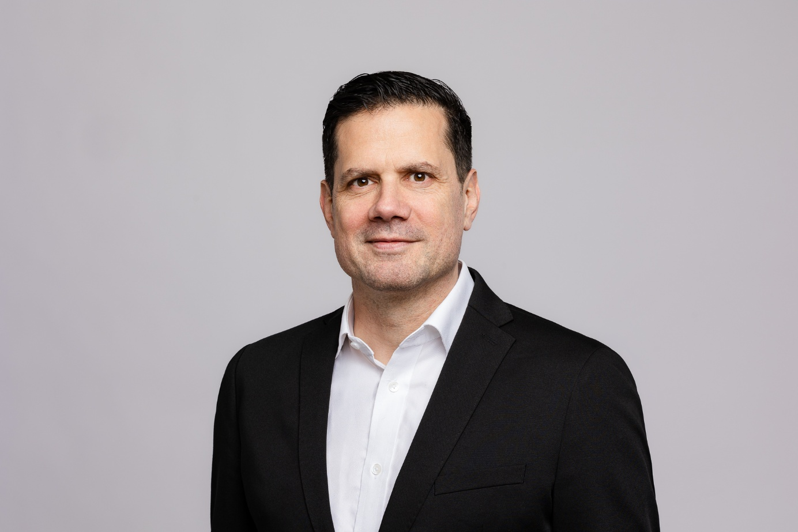
Torsten Blaschke, CFO at congatec

San Diego, CA, February 18, 2026 * * * congatec – the leading vendor of embedded and edge computing technology – is strengthening its management team with the appointment of Torsten Blaschke as Chief Financial Officer (CFO). In his new role, he will support congatec’s continued globalization and market leadership while driving the company’s global growth.

Torsten Blaschke joins the executive leadership team alongside CEO Dominik Ressing and COO & CTO Konrad Garhammer, bringing decades of management experience from leading companies across a range of industries. Most recently, Blaschke served as Group CFO of the service provider doctari group. Prior to that, he spent nearly 20 years in senior leadership roles at the consulting firm EY.

Blaschke brings his many years of expertise to help advance congatec as a global player. “congatec already stands for technological excellence, innovation, and a broad, future-oriented portfolio of embedded computing technologies. My goal is to further strengthen congatec, establish new business models, and steadily increase profitability. I am very much looking forward to financially steering the market leader in application-ready embedded computing technologies,” said Blaschke.

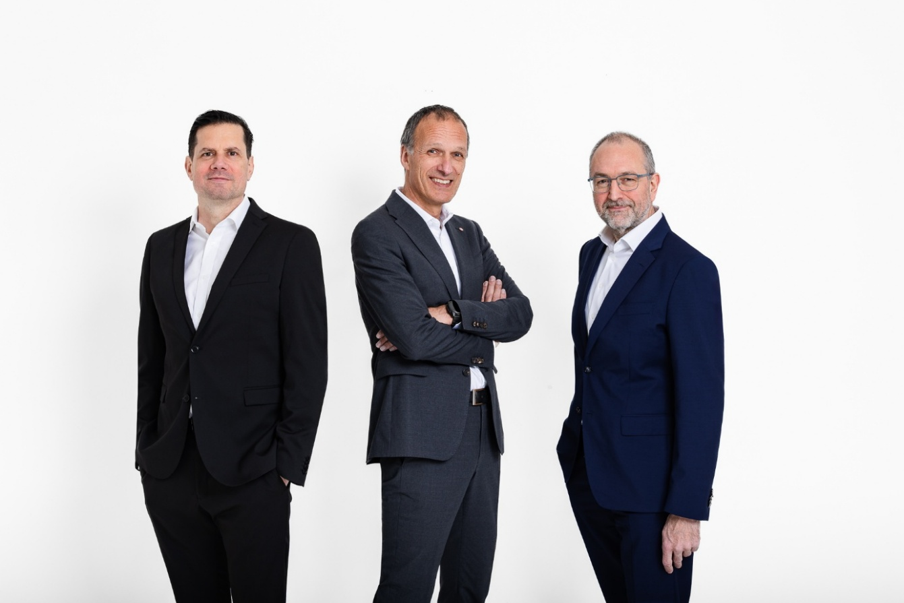
From left to right: Torsten Blaschke (CFO), Dominik Ressing (CEO), Konrad Garhammer (COO & CTO)

“As CEO of congatec, I am pleased to welcome Torsten Blaschke to our company and look forward to working with him,” said Dominik Ressing. “With his many years of leadership experience in international organizations, Torsten adds valuable strategic and financial expertise to our innovation and technology strengths. He will support us in addressing markets in a more targeted manner and in building sustainable business models that deliver even greater value to our customers in automation, medical technology, robotics, transportation, energy, and communications. We are gaining a CFO who will secure our market position financially and sustainably expand and strengthen congatec’s market leadership,” Ressing said.

Konrad Garhammer, COO & CTO of congatec, added: “With Torsten’s expertise, we will be able to further expand our aReady. portfolio, comprising application-ready hardware and software building blocks as well as services. This will enable us to provide our embedded computing customers with more and easier-to-use value-added offerings in areas such as AI, security, and ruggedness - helping them further enhance the value, business models, and time-to-dollar of their applications.”

* * *

About congatec
congatec is the leading global provider of high-performance hardware and software building blocks for embedded and edge computing solutions based on Computer-on-Modules (COMs). These advanced computer modules drive systems and devices across industries such as industrial automation, medical technology, robotics, telecommunications, and more. congatec's high-performance aReady. ecosystems simplify and accelerate the solution development, from COM to cloud. This application-ready approach combines COMs with services and customizable technologies that enable cutting-edge advancements in system consolidation, IoT, security, and artificial intelligence. Supported by its majority shareholder, DBAG Fund VIII – a German mid-market fund focused on driving growth for industrial enterprises – congatec has the financial backing and M&A expertise to capitalize on expanding market opportunities. For more information, visit congatec.com, aReady.com, or follow us on LinkedIn and YouTube.

Reader Enquiries:
congatec
Dan Demers
Phone: 858-457-2600
Dan.Demers@congatec.com
www.congatec.us

Press Contact:
congatec
Janene Rae
Phone: 858-457-2600
janene.rae@congatec.com
www.congatec.us

