
Press release

Scalable Edge Performance for Demanding Applications

conga-TCRP1 combines high performance with maximum scalability and design flexibility

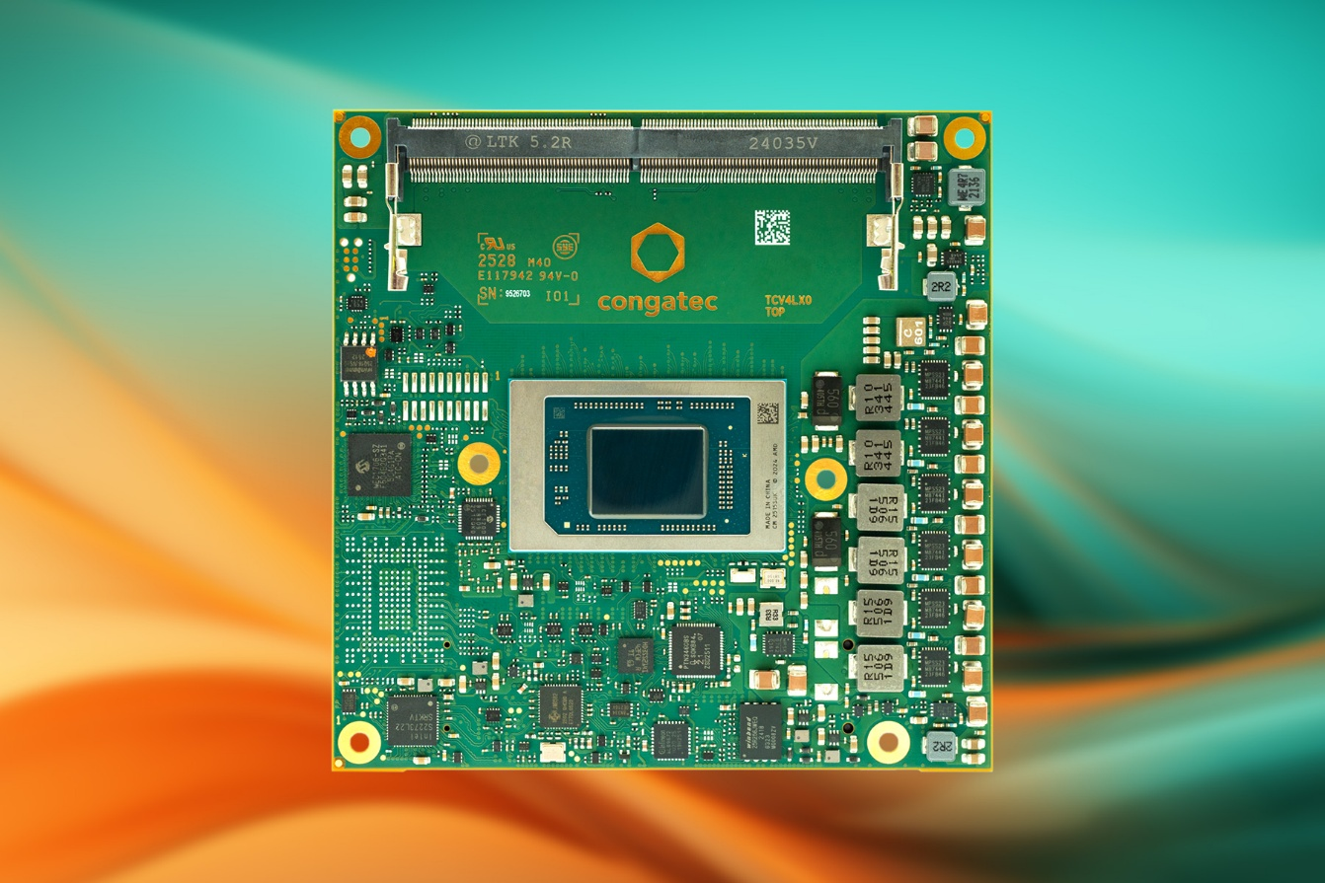
Deggendorf/Nuremberg, Germany, March 10, 2026 * * * congatec – the leading vendor of embedded and edge computing technology – is enhancing the performance and scalability of its AMD Ryzen™ AI Embedded P100 Series COM Express 3.1 Type 6 Compact modules. The conga-TCRP1 is now available in six new variants with eight, ten, or twelve CPU cores. This makes them an ideal fit for cost-sensitive designs that require a highly flexible and scalable embedded computing platform. Developers can now seamlessly scale from 4 to 12 CPU cores and from 2 to 16 graphics compute units, achieving an optimized balance of CPU, GPU, and NPU resources.

Customers can use just one module variant for various designs, ranging from passively cooled, fully enclosed designs for robust handheld devices and hygienic medical PCs to mission computers for harsh environments and high-performance system designs.

The new COM Express compact modules leverage the advanced AMD “Zen 5” and “Zen 5c” CPU architecture with 4-nm technology to deliver enhanced determinism for real-time and latency-sensitive workloads. Additional performance gains are achieved through the integrated Radeon RDNA 3.5™ GPU and the XDNA2™ NPU with up to 50 TOPS of AI compute capability. This powerful computing architecture accelerates performance-intensive and deterministic edge AI applications across industries including transportation, medical technology, smart city infrastructure, gaming, robotics, and industrial automation.

High compute density particularly benefits mobile medical imaging devices such as ultrasound systems, AI-powered industrial machine vision solutions for automated quality inspection, as well as traffic monitoring and surveillance systems in smart cities including extended temperature deployments for wayside installations. The modules are also ideally suited for professional gaming applications.

“The expansion of the conga-TCRP1 portfolio underscores the strength and scalability of the AMD Ryzen™ AI Embedded P100 Series,” Amey Deosthali, Sr. Director for Industrial, Robotics, and Healthcare, AMD. “From compact, passively cooled medical and industrial systems to rugged mission-critical edge deployments, the conga-TCRP1 modules enable customers to seamlessly scale their product portfolio, accelerate time-to-market, and unlock new levels of performance-per-watt for next-generation embedded and edge AI applications.”

“All conga-TCRP1 variants are configurable across an exceptionally wide TDP range from 15 to 54 watts,” explains Florian Drittenthaler, Product Line Manager at congatec. “This allows customers to precisely tailor the performance-per-watt profile to their specific application and realize multiple performance tiers using a single module design. It enables easy adaptations during the project lifecycle without requiring a platform change, a key advantage for applications designed according to strict Size, Weight, Power, and Cost (SWaP-C) requirements. The result is flexibility to design a complete product family with just one module family, improving time-to-market, TCO (Total Cost of Ownership) and RoI (Return on Investment) for various designs from handheld devices to high-performance mission computers operating in harsh environments.”

The Feature Set in Detail
The conga-TCRP1 COM Express compact modules are available with ten different AMD Ryzen Embedded P100 Series processors. In addition to up to 12 Zen5/5c cores and Radeon RDNA 3.5™ GPU - supporting up to four independent displays with immersive 4K graphics. The integrated XDNA2™ NPU delivers up to 50 TOPS of AI performance. This enables local, real-time execution of smaller large language models (LLMs) without cloud connectivity or discrete accelerators, improving data security while reducing cooling requirements. The NPU can simultaneously handle tasks such as anomaly detection, visual inspection, and optical character recognition (OCR) alongside ongoing system operations. Memory-intensive applications benefit from up to 96 GB DDR5-5600 RAM, with optional ECC support for mission-critical deployments. For high-speed data transfer and low-lane peripheral integration, including Industrial Ethernet, fieldbus adapters, or wireless modules, the module provides up to eight fully configurable PCIe Gen4 lanes plus PEG x4 Gen4.

Further connectivity features include 2.5 GbE for high-speed networking, four USB 3.2 Gen2 ports, and four USB 2.0 ports. Storage options include up to 512 GB onboard NVMe SSD or dual SATA 6 Gb/s interfaces for external media. Additional interfaces include I²C, SPI, two UARTs, eight GPIOs, SMBus, and LPC. An additional PCIe switch on the carrier board can be eliminated, simplifying overall system design.

Supported operating systems include Microsoft Windows 11, Windows 11 IoT Enterprise, Linux, ctrlX OS, Ubuntu Pro, and Kontron OS. As application-ready aReady.COM modules, they can be preconfigured with licensed ctrlX OS, Ubuntu Pro, or Kontron OS. The aReady.VT option with integrated Hypervisor-on-Module technology enables consolidation of multiple workloads, such as real-time control, HMI, AI processing, and IoT gateway functions, onto a single module. For IIoT (Industrial Internet of Things) connectivity, congatec provides aReady.IOT software building blocks supporting data exchange, remote updates, maintenance, and management of the module, carrier board, and peripherals, as well as optional cloud integration. To further streamline development, congatec offers a comprehensive ecosystem. This includes evaluation and application-ready carrier boards, as well as aReady.YOURS customization services for COM, carrier, and cooling solutions, right through to fully customized designs.

Available Variants
The new conga-TCRP1 modules are available in the following configurations:
Model | Cores Threads) | Graphics CUs | max. Boost | Base-TDP | Operating Temp.
conga-TCRP1 P185 | 12 / 24 | 16 | 5.1 GHz | 28 (15-54 W) | 0 to +60 °C
conga-TCRP1 P174 | 10 / 20 | 12 | 5.0 GHz | 28 (15-54 W) | 0 to +60 °C
conga-TCRP1 P164 | 8 / 16 | 12 | 5.0 GHz | 28 (15-54 W) | 0 to +60 °C
conga-TCRP1 P132 | 6 / 12 | 4 | 4.5 GHz | 28 (15-54 W) | 0 to +60 °C
conga-TCRP1 P121 | 4 / 8 | 2 | 4.4 GHz | 28 (15-54 W) | 0 to +60 °C
conga-TCRP1 P185i | 12 / 24 | 16 | 5.1 GHz | 28 (15-54 W) | -40 to +85 °C
conga-TCRP1 P174i | 10 / 20 | 12 | 5.0 GHz | 28 (15-54 W) | -40 to +85 °C
conga-TCRP1 P164i | 8 / 16 | 12 | 5.0 GHz | 28 (15-54 W) | -40 to +85 °C
conga-TCRP1 P132i | 6 / 12 | 4 | 4.5 GHz | 28 (15-54 W) | -40 to +85 °C
conga-TCRP1 P121i | 4 / 8 | 2 | 4.4 GHz | 28 (15-54 W) | -40 to +85 °C
For more information about the COM Express Type 6 Compact module conga-TCRP1, please visit: https://www.congatec.com/en/products/com-express-type-6/conga-tcrp1/
* * *
About congatec
congatec is the leading global provider of high-performance hardware and software building blocks for embedded and edge computing solutions based on Computer-on-Modules (COMs). These advanced computer modules drive systems and devices across industries such as industrial automation, medical technology, robotics, telecommunications, and more. congatec's high-performance aReady. ecosystems simplify and accelerate the solution development, from COM to cloud. This application-ready approach combines COMs with services and customizable technologies that enable cutting-edge advancements in system consolidation, IoT, security, and artificial intelligence. Supported by its majority shareholder, DBAG Fund VIII – a German mid-market fund focused on driving growth for industrial enterprises – congatec has the financial backing and M&A expertise to capitalize on expanding market opportunities. For more information, visit congatec.com, aReady.com, or follow us on LinkedIn and YouTube.

AMD, the AMD logo, Ryzen, and combinations thereof are trademarks of Advanced Micro Devices, Inc.

Reader enquiries:
congatec
Phone: +49-991-2700-0
info@congatec.com
www.congatec.com

Press contact congatec:
congatec
Christof Wilde
Phone: +49-991-2700-2822
christof.wilde@congatec.com

