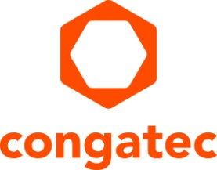
Press release

congatec launches aReady.YOURS Partner Program for market-specific system solutions

congatec and Kontron partner on embedded computing solutions

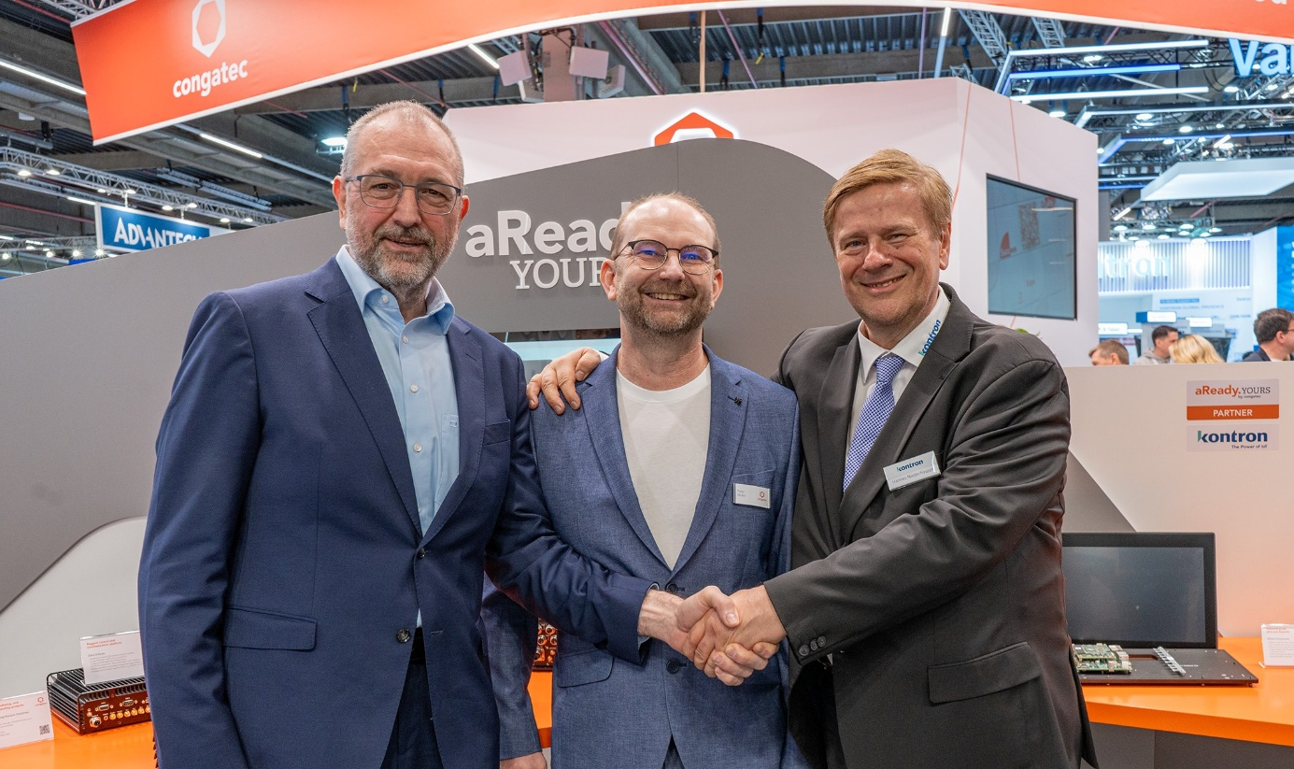

San Diego, CA, March 10, 2026 * * * congatec – the leading provider of embedded and edge computing technology – is expanding its portfolio of customized embedded computing platforms. With the launch of the aReady.YOURS Partner Program, the company is strengthening its ability to deliver added value to OEMs. The aim is to work with solution partners to develop turnkey systems for markets with strict regulatory and complex technical requirements.

Within aReady.YOURS, congatec will lead the development of integrated embedded computing platforms, including low-level software building blocks such as operating systems, IoT connectivity, and hypervisors for system consolidation. The aReady.YOURS partner will take responsibility for key aspects of the system design, including enclosures, application-specific interfaces, and required certifications. This significantly reduces the time OEMs spend on foundational development work. Instead, they can focus on their core competencies while benefiting from faster system development, high design reliability, reduced implementation effort, and improved solution profitability.

Kontron becomes the first aReady.YOURS partner
congatec’s first aReady.YOURS solution partner is Kontron. Under the terms of the existing partnership, congatec modules are integrated into Kontron’s modular standard systems – most recently also Arm-based modules featuring Qualcomm® Dragonwing IQ-X processors. aReady.YOURS expands the collaboration to include custom designs that go beyond standard systems. Thanks to the streamlined workflows established through previous joint projects, customers benefit from greater agility and faster time-to-market.

In addition, congatec‘s aReady.YOURS development team – following the acquisition of Kontron’s module business – has deep expertise in the design of embedded platforms for Kontron systems. Together, the companies primarily address highly regulated markets, including avionics, railway, communications, transportation, medical, industrial automation, robotics, and other verticals that demand rugged, certified system designs. Kontron contributes extensive experience from previous system developments, successful certification projects, and 5G connectivity for mobile edge applications. Geographically, the partnership focuses on North America and the EMEA region.

“With aReady.YOURS, we are taking customized designs to a new level: faster, more reliable, and closely aligned with the requirements of our OEMs and their customers. Partnering with Kontron as our first aReady.YOURS partner is a key element of this strategy. Customers benefit from complete application-specific systems – including certifications – which further relieves them from time-consuming foundational development work,” explains Konrad Garhammer, COO & CTO at congatec.

“With this move, Kontron and congatec are deepening their partnership. As a global leader in IoT and embedded computing technologies, Kontron contributes comprehensive expertise in hardware, software, and system design that perfectly complements congatec’s application-ready board and module portfolio. Our closer collaboration gives OEMs access to complete, highly integrated embedded systems with ‘Designed-in-Germany’ quality – offering faster time-to-market, high supply reliability, and long-term lifecycle support,” says Hannes Niederhauser, CEO at Kontron AG, highlighting the value of the aReady.YOURS partnership.

“With disruptive technologies such as AI and increasingly complex certification requirements, our customers need ready-to-use embedded systems to fully focus on their core competencies. Customized embedded computing solutions that are engineered to exacting standards and fully certified provide clear advantages in design reliability, time-to-market, and total cost of ownership,” says Peter Müller, VP Global Customer Application Center at congatec.

For more information, please visit https://www.congatec.com/aready-yours/

* * *
About congatec
congatec is the leading global provider of high-performance hardware and software building blocks for embedded and edge computing solutions based on Computer-on-Modules (COMs). These advanced computer modules drive systems and devices across industries such as industrial automation, medical technology, robotics, telecommunications, and more. congatec's high-performance aReady. ecosystems simplify and accelerate the solution development, from COM to cloud. This application-ready approach combines COMs with services and customizable technologies that enable cutting-edge advancements in system consolidation, IoT, security, and artificial intelligence. Supported by its majority shareholder, DBAG Fund VIII – a German mid-market fund focused on driving growth for industrial enterprises – congatec has the financial backing and M&A expertise to capitalize on expanding market opportunities. For more information, visit congatec.com, aReady.com, or follow us on LinkedIn and YouTube.

Reader Enquiries:
congatec
Dan Demers
Phone: 858-457-2600
Dan.Demers@congatec.com
www.congatec.us

Press Contact:
congatec
Janene Rae
Phone: 858-457-2600
janene.rae@congatec.com
www.congatec.us

