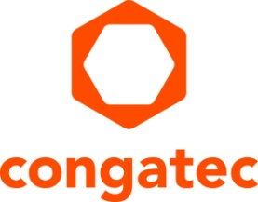
Press release

congatec centralizes customization design and software integration services in new Customer Application Center and launches aReady.YOURS

aReady.YOURS from congatec for fast and reliable (full) custom embedded computing designs

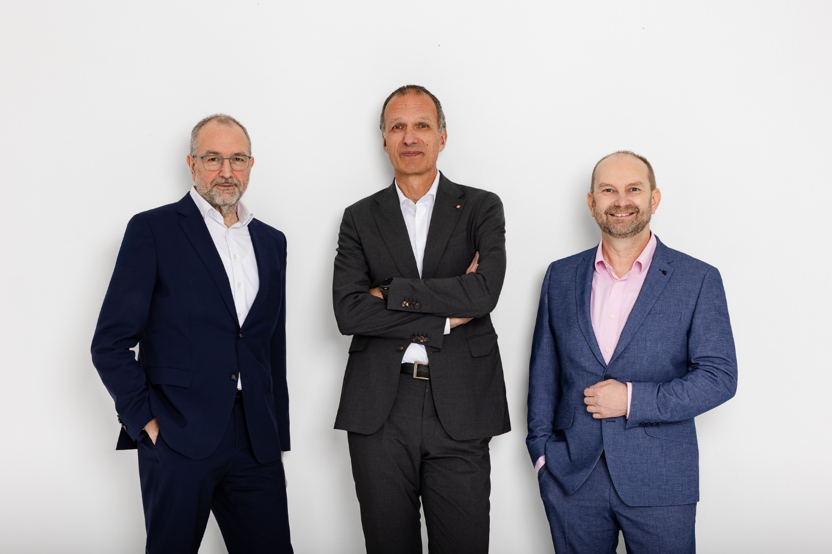
Konrad Garhammer (CTO & COO), Dominik Ressing (CEO), and Peter Müller (VP Global Customer Application Center) present congatec’s new customization and software integration services aReady.YOURS (from left to right).

Deggendorf/Nuremberg, Germany, March 10, 2026 * * * congatec – the leading provider of embedded and edge computing technology – today announced its new Customer Application Center and the launch of aReady.YOURS. With this move, congatec expands its aReady. hardware and software building blocks portfolio to include comprehensive customization design and software integration services, delivering near turnkey embedded computing platforms to OEM customers. aReady.YOURS supports customers throughout every phase of development – from requirements engineering and design to series production and lifecycle management. The goal is to bring tailored embedded computing platforms – complete with advanced cooling solutions – from concept to rollout quickly and reliably. With this new offering, congatec further optimizes time-to-market and design reliability for OEMs that rely exclusively on full-custom designs for cost and efficiency reasons.

COM-carrier fusion accelerates development
On the hardware side, congatec leverages its proven Computer-on-Module (COM) technologies, cooling solutions, and existing carrier board layouts. This ensures high design reliability and shorter development cycles, as only customer-specific adaptations are required. Through COM-carrier fusion, full-custom designs can be implemented highly efficiently based on validated, field-proven designs. Customers can begin application development immediately using the selected module, an evaluation carrier, and the appropriate cooling solution – further accelerating time-to-market. Thanks to congatec’s manufacturing partnership with technology partner Kontron, solution platforms can be scaled to series production under a “local-for-local” strategy, enabling regional manufacturing in target regions.

Application-ready platforms with aReady.COM, aReady.VT, and aReady.IOT
Upon request, congatec also integrates suitable software building blocks from its aReady. portfolio. These include customized firmware, pre-installed, configured, and licensed operating systems such as ctrlX OS, Ubuntu Pro, and Kontron OS from aReady.COM, the conga-zones hypervisor for system consolidation from aReady.VT, and conga-connect IoT stacks from aReady.IOT. Customers receive a fully configured, tested, and licensed system that is optimally aligned with their application. The close integration of hardware and software significantly reduces implementation effort and shortens validation cycles. The result is faster deployment and an earlier, optimized return on investment.

“Through the strategic acquisition of our partner Kontron’s module business, we have built the capabilities to launch the Customer Application Center and aReady.YOURS, allowing us to offer customized designs as a standard service. In addition, we are establishing a strong partner ecosystem to deliver industry-specific custom designs and system certifications. This positions us as a full-service partner for our customers’ entire embedded computing needs – from development and manufacturing to deployment and lifecycle management,” explains Dominik Ressing, CEO at congatec, outlining the expanded aReady. strategy.

“As a leading manufacturer of application-ready COMs for embedded computing solutions, we can scale highly efficiently. By combining our high-quality COM and carrier board designs, we can deliver customer-specific full-custom designs quickly and with high design reliability. Customers benefit from reduced time-to-dollar, optimized system costs, and ultimately higher profitability,” adds Konrad Garhammer, COO & CTO at congatec.


Peter Müller, VP Global Customer Application Center

“With aReady.YOURS, we significantly lower the entry cost and effort associated with full-custom designs. At the highest configuration level, we deliver a fully application-specific embedded computing platform that includes all functional components, except for the housing and the customer’s proprietary software: a full-custom board, installed and licensed operating systems, an integrated IoT instance, and – if required – a hypervisor,” concludes Peter Müller, VP Global Customer Application Center.

aReady.YOURS technical services at a glance
1. Custom hardware and software design services encompass the development of customer-specific modules including cooling solutions and carrier boards, as well as fully customized Single Board Computers (SBC) including series production.

2. Individual hardware and software consulting supports customers with detailed requirements engineering tailored to their specific applications. This collaborative approach ensures that the finished solution is precisely aligned with target market requirements.

3. Technical support and debugging ensure that customized solution platforms operate reliably on both hardware and software.

4. Extended product lifecycle services include reactivation of standard products, strategic material stockpiling, and flexible license production models.

For more information, please visit https://www.congatec.com/aready-yours/

* * *
About congatec
congatec is a leading global provider of high-performance hardware and software building blocks for embedded and edge computing solutions based on Computer-on-Modules (COMs). These advanced computer modules drive systems and devices across industries such as industrial automation, medical technology, robotics, telecommunications, and more. congatec's high-performance aReady. ecosystems simplify and accelerate the solution development, from COM to cloud. This application-ready approach combines COMs with services and customizable technologies that enable cutting-edge advancements in system consolidation, IoT, security, and artificial intelligence. Supported by its majority shareholder, DBAG Fund VIII – a German mid-market fund focused on driving growth for industrial enterprises – congatec has the financial backing and M&A expertise to capitalize on expanding market opportunities. For more information, visit www.congatec.com or follow us on LinkedIn and YouTube.

Reader enquiries:
congatec
Phone: +49-991-2700-0
info@congatec.com
www.congatec.com

Press contact congatec:
congatec
Christof Wilde
Phone: +49-991-2700-2822
christof.wilde@congatec.com

