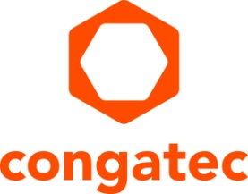
Press Release

New COM Express modules with Intel Core Series 3 processors for cost- and energy-optimized embedded computing applications

conga-TC300 – the ideal entry point into edge AI

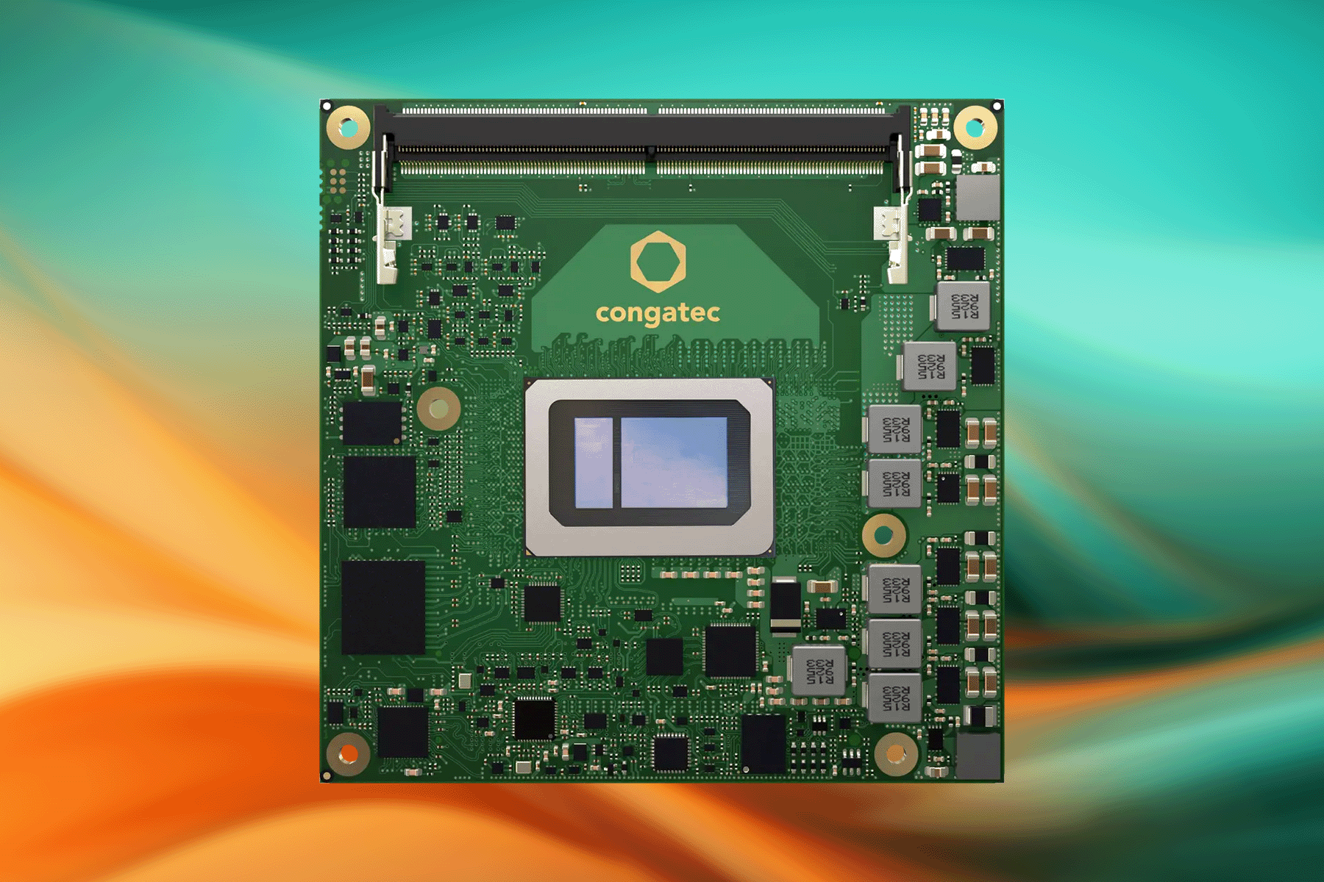

Deggendorf, April 16, 2026 * * * congatec – a leading provider of embedded and edge computing technology – introduces the conga-TC300 Computer-on-Module (COM) in the COM Express Compact form factor, based on Intel Core Series 3 processors (codename: Wildcat Lake). With this, the application-ready aReady.COM modules bring dedicated AI accelerators to the low-power and entry-level segment of x86-based embedded and industrial edge applications for the first time. They are an ideal upgrade for all embedded designs that previously used Intel Atom or Celeron platforms but now need to be expanded with dedicated AI capabilities. The conga-TC300 is specifically designed for cost-sensitive edge AI applications in markets such as robotics, industrial automation, medical technology, transportation, smart cities, and retail/point-of-sale (POS).

With the Intel Core Series 3 processors, the new modules bring numerous high-end features to the entry-level segment. These include improved energy efficiency thanks to two Performance cores (P-cores) and four Low Power Efficient cores (LP E-cores), which deliver up to 5 TOPS thanks to Intel 18A. They are also the first Intel Core modules with a dedicated NPU capable of up to 18 TOPS. In addition, there are up to two Xe3 graphics cores for GPGPU-accelerated AI applications, also delivering up to 18 TOPS. In total, developers can access up to 41 TOPS of AI performance. And all this within an economical Thermal Design Power (TDP) envelope that can be scaled from 12 to 28 W—with a 15 W base TDP—to suit various use cases.

“With the conga-TC300, we are opening up a reliable upgrade path to new AI capabilities with up to ten years of availability for low-power and lightweight AI applications. With our new COM Express module, OEMs can easily equip applications such as Autonomous Guided Vehicles (AGVs) and Autonomous Mobile Robots (AMRs), intelligent machine controls, HMIs, Patient Data Monitoring Systems (PDMS), surveillance, or check-in and check-out terminals with new AI features. Whether it’s local voice or gesture control, AI-assisted object recognition and identification, or LLM-based dialogue functions, developers looking for cost- and energy-efficient AI performance will be very pleased with the conga-TC300,” explains Jürgen Jungbauer, Senior Product Line Manager at congatec.

The module in detail
The conga-TC300 integrates up to 64 GB of DDR memory with speeds of up to 6400 MT/s and optional in-band Error Correction Code (IBECC). Up to 512 GB of onboard UFS 3.1 storage is also available as an option. Networked applications benefit from 2.5 Gigabit Ethernet (GbE), optionally with Time-Coordinated Computing (TCC) and Time-Sensitive Networking (TSN). Up to eight freely configurable PCIe lanes are available for fast data transfer and the connection of low-lane peripherals such as Ethernet, fieldbus adapters, or wireless modules. This eliminates the need for an additional PCIe switch on the carrier board, further simplifying the design.

Up to two DDI ports, one LVDS port, or one eDP port are available for connecting displays. Additional interfaces include up to 2x USB4, 4x USB3.2, 4x USB2.0, 2x SATA, 2x UART, GPIOs, GP SPI, eSPI, SM Bus, HDA, and I2C. On the software side, congatec supports users with a Board Management Controller, multi-stage watchdog, and various embedded BIOS features. A Trusted Platform Module (TPM 2.0) ensures the necessary security.

Supported operating systems include Microsoft Windows 11, Windows 11 IoT Enterprise, and Linux. As application-ready aReady.COMs, the modules are available preconfigured with licensed ctrlX OS, Ubuntu Pro, and KontronOS operating systems. The aReady.VT option, featuring integrated conga-zones hypervisor and virtualization technologies, enables developers to consolidate multiple workloads—such as real-time control, HMI, AI, and IoT gateway functions—onto a single module. For IIoT connectivity, congatec offers aReady.IOT software building blocks. As conga-connect, they enable data exchange, remote maintenance, and management of the module, carrier boards, and peripherals, as well as cloud connectivity, as needed. To further simplify application development, congatec offers a comprehensive supporting ecosystem that includes evaluation and application carrier boards, customized cooling solutions, comprehensive documentation, design-in services, and high-speed signal integrity measurements. With aReady.YOURS, OEMs can also take advantage of congatec’s comprehensive hardware and software customization services to obtain turnkey-level embedded computing platforms, including advanced cooling solutions.

The new conga-TC300 processor variants at a glance:
CPU |  | Cores/  (P + LP E) |  | P-cores Base  Frequency [GHz] |  | P-cores  max. Turbo Frequency [GHz] |  |  | Graphic EUs |  | CPU Base Power [W]
Intel Core 7 350 |  | 6 (2+4) |  | 1,5 |  | 4,8 |  |  | 32 |  | 15
Intel Core 5 320 |  | 6 (2+4) |  | 1,5 |  | 4,6 |  |  | 32 |  | 15
Intel Core 3 305 |  | 6 (2+4) |  | 1,5 |  | 4,3 |  |  | 16 |  | 15

Further information on the new conga-TC300 Computer-on-Module can be found at: https://www.congatec.com/en/products/com-express-type-6/conga-tc300

***

About congatec
congatec is a leading global provider of high-performance hardware and software building blocks for embedded and edge computing solutions based on Computer-on-Modules (COMs). These advanced computer modules drive systems and devices across industries such as industrial automation, medical technology, robotics, telecommunications, and more. congatec's high-performance aReady. ecosystems simplify and accelerate the solution development, from COM to cloud. This application-ready approach combines COMs with services and customizable technologies that enable cutting-edge advancements in system consolidation, IoT, security, and artificial intelligence. Supported by its majority shareholder, DBAG Fund VIII – a German mid-market fund focused on driving growth for industrial enterprises – congatec has the financial backing and M&A expertise to capitalize on expanding market opportunities. For more information, visit www.congatec.com or follow us on LinkedIn and YouTube.

Intel, the Intel logo, and other Intel marks are trademarks of Intel Corporation or its subsidiaries.

Reader enquiries:
congatec
Phone: +49-991-2700-0
info@congatec.com
www.congatec.com

Press contact congatec:
congatec
Christof Wilde
Phone: +49-991-2700-2822
christof.wilde@congatec.com

